**Exercise 6 – Rafael José – 22202078**

*The man who lost his dog:*

Our main character is a man named John who has just lost his beloved dog, Max. John is devastated and decides to search for Max no matter what it takes. He sets out on a journey, determined to find his furry friend.

Along the way, John can meet three different people who offer to help him in his search. A kind old woman named Mary who tells John about a beautiful park where Max might be hiding. A young boy named Billy who offers to help John search for Max in the nearby woods. A friendly police officer named Sam who tells John about a lost and found center where he might be able to find Max.

The story can take place in locations, the park, the woods, the lost and found center, John's home, and the streets. John can visit each location, following leads and searching for any sign of Max. In the park, he meets a group of friendly dogs who seem to know Max and lead him to a hidden spot where Max is waiting for him. John is overjoyed to be reunited with his beloved dog and thanks the other people for their help.

Together, John and Max return home, grateful for the adventure and the help of their new friends. They are happy to be reunited and spend the rest of their days enjoying each other's company.

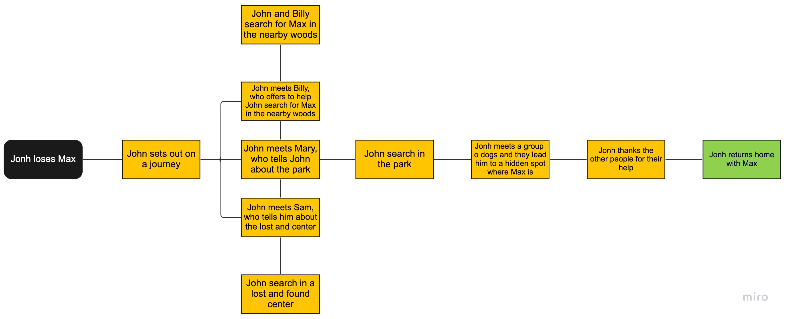

**Story Flowchart:**

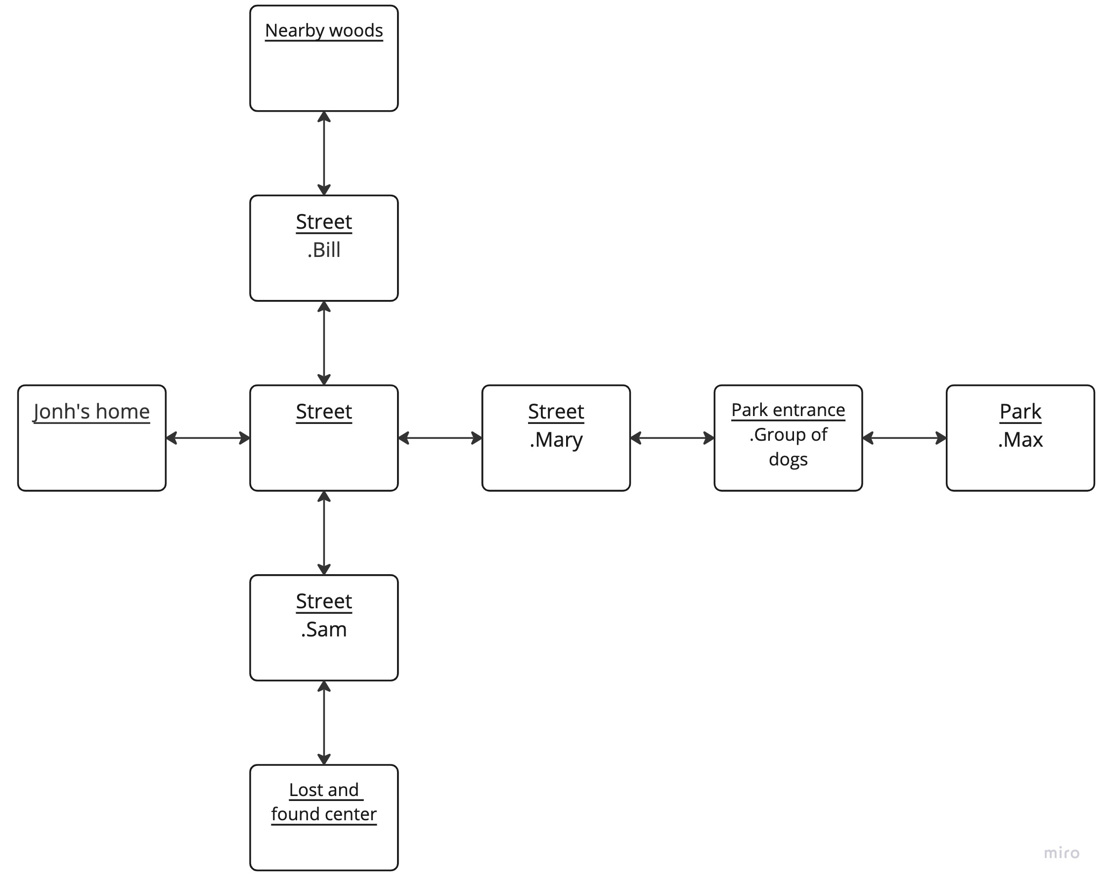

**Location Layout:**

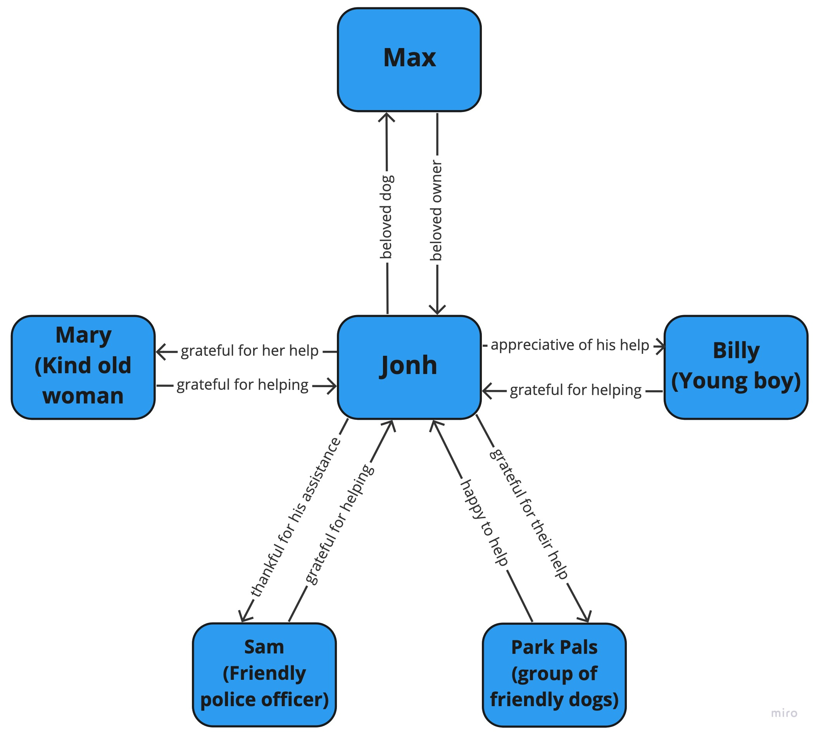

**Character Relationship graph:**